# CS 255 System Design Document Template

## UML Diagrams

### UML Use Case Diagram

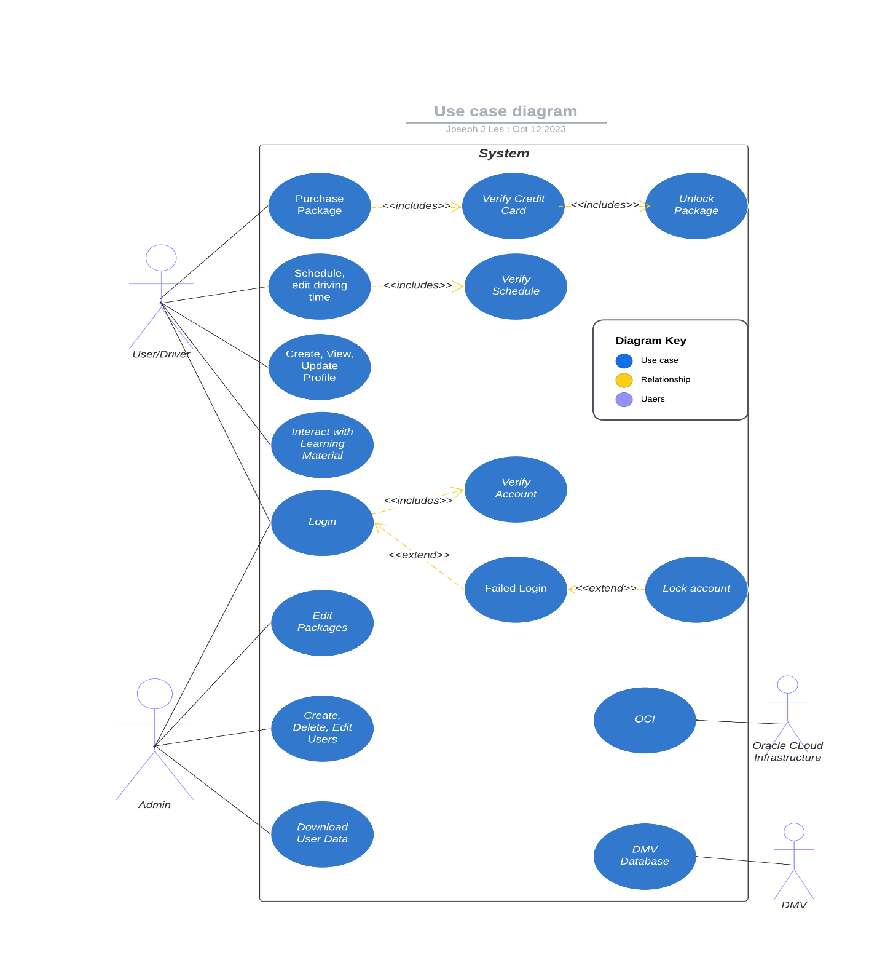

### UML Activity Diagrams

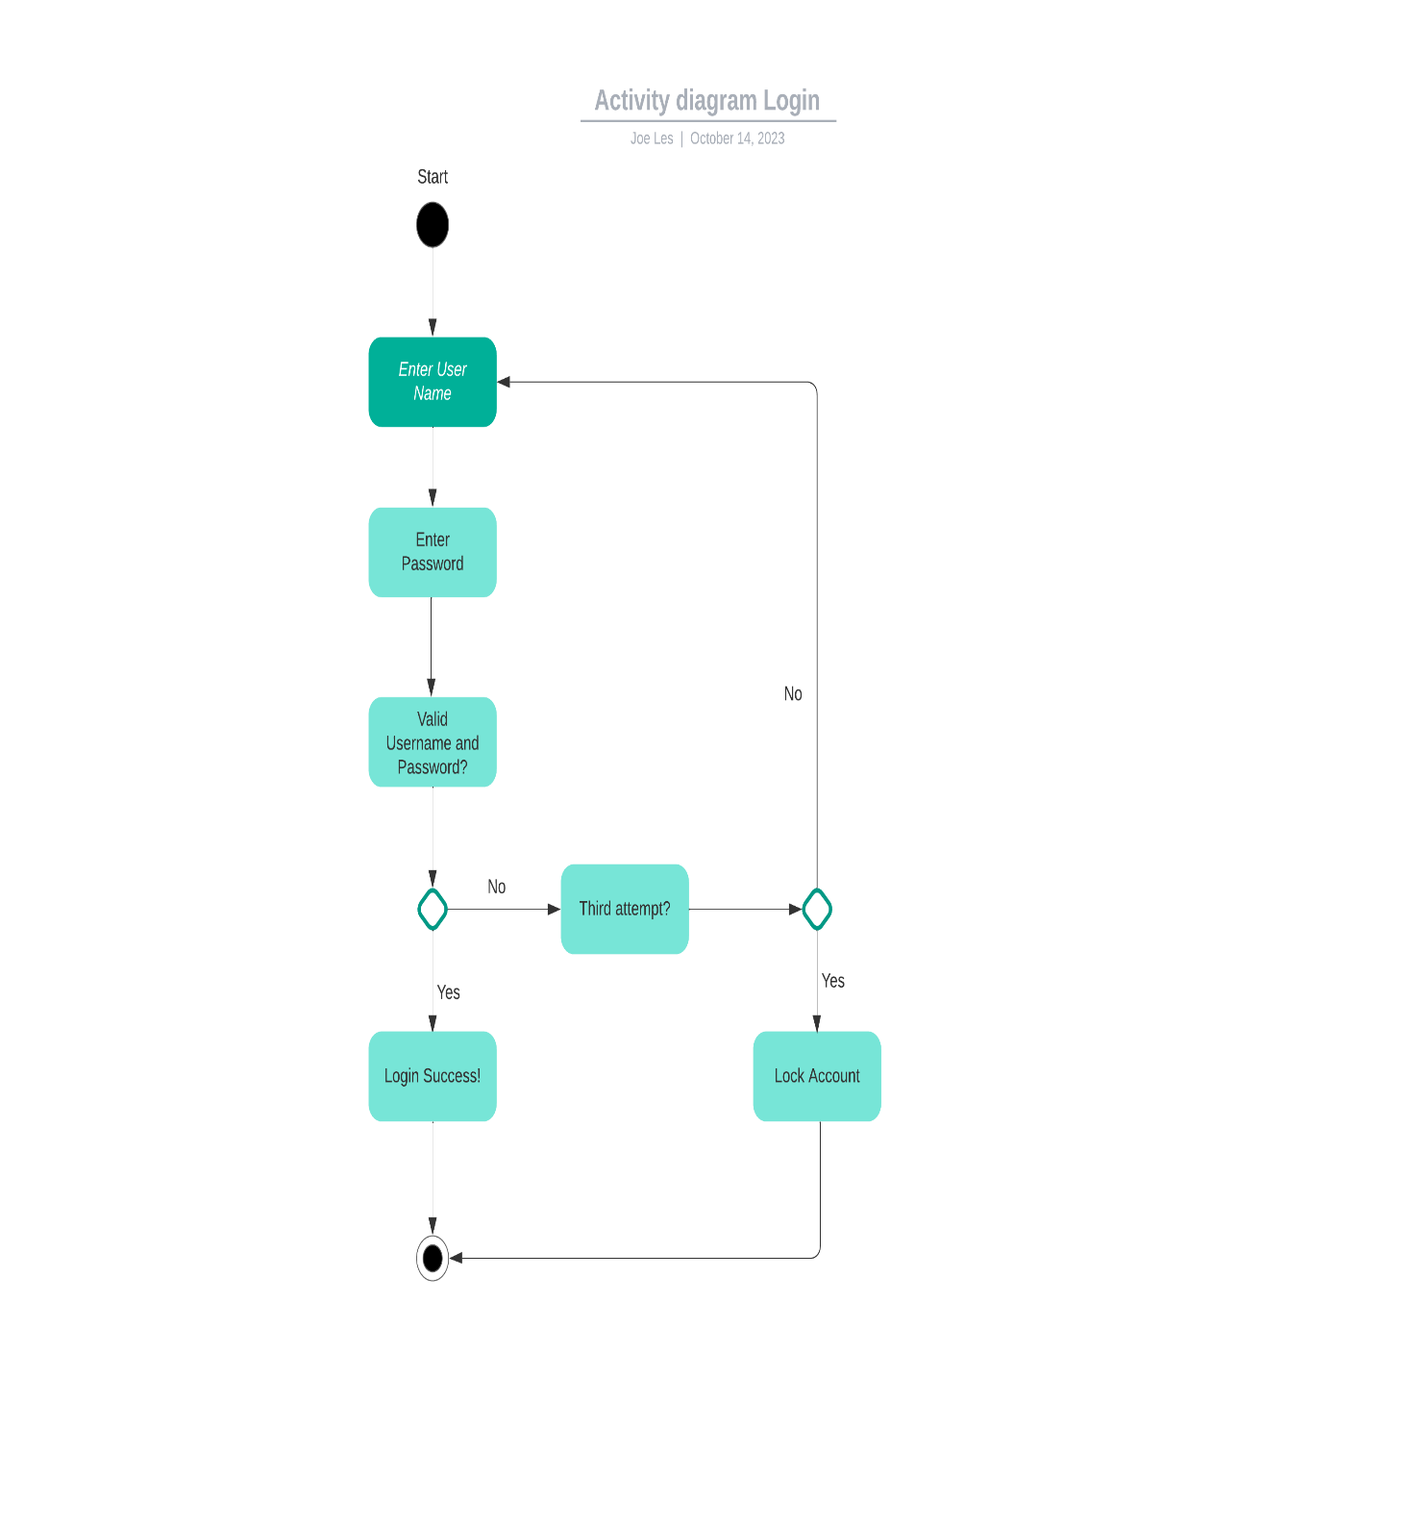

### 

### UML Sequence Diagram

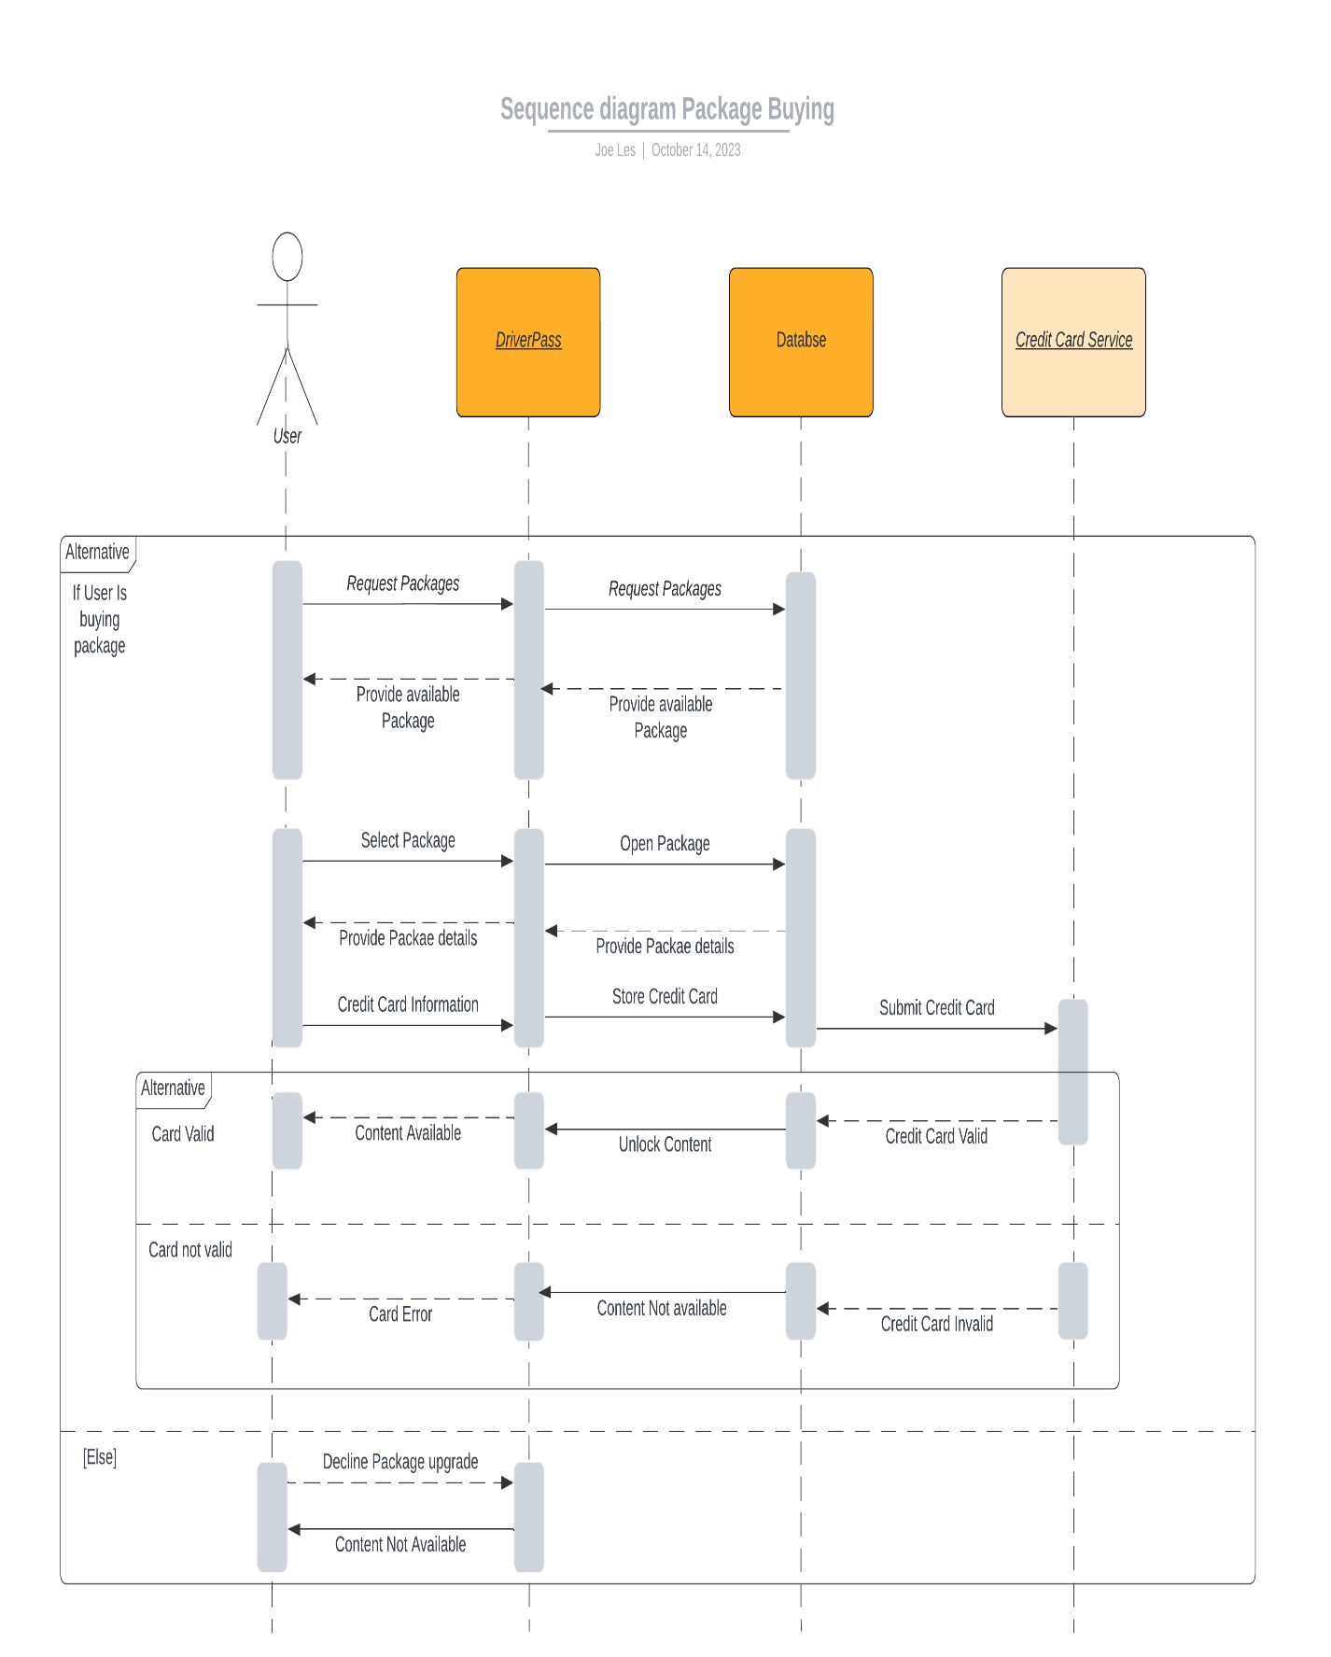

### UML Class Diagram

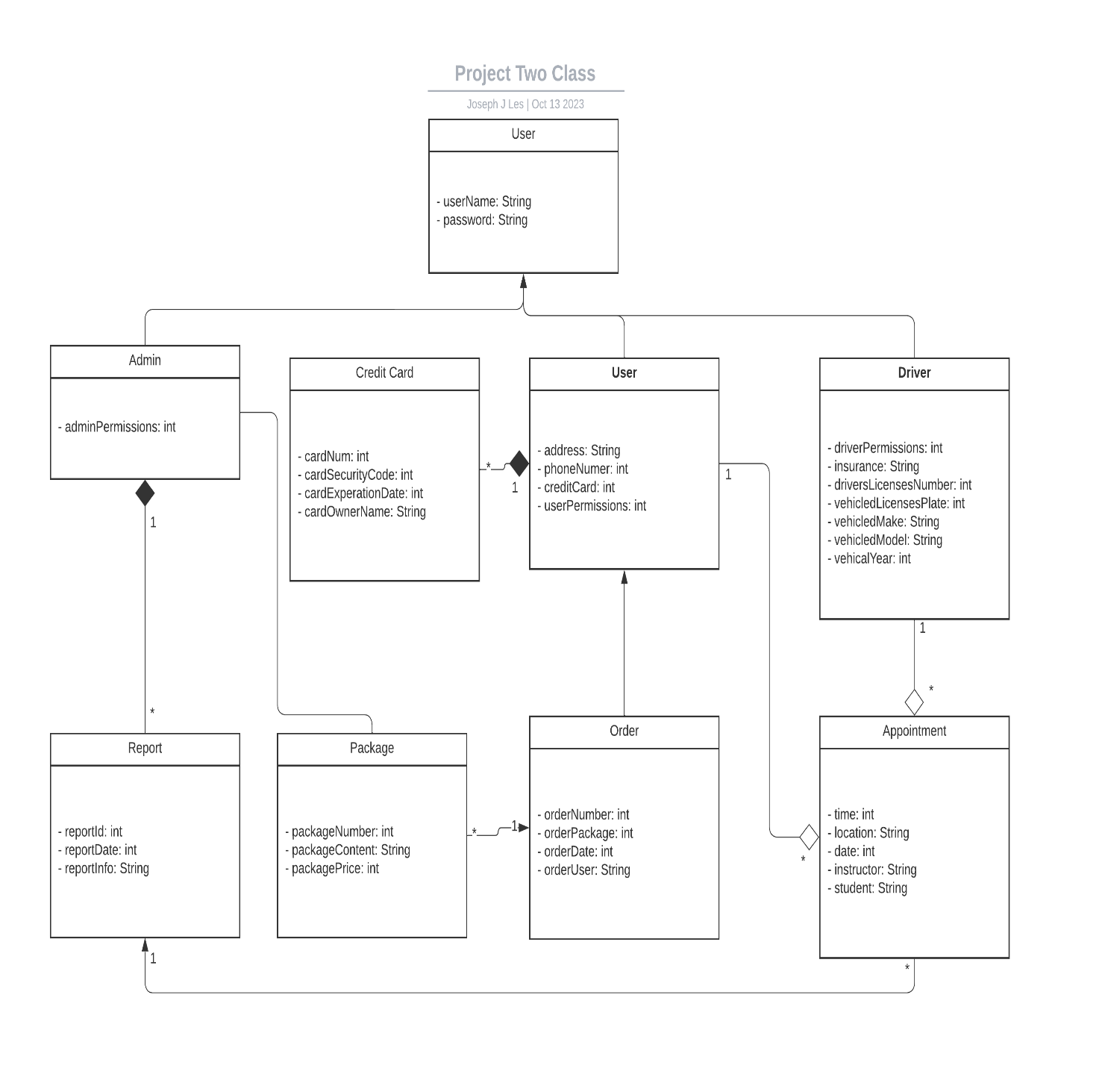

## Technical Requirements

**Technical requirements for Hardware**

**DriverPass hosting on OCI (Oracle Cloud Infrastructure):**

* Compute instance
  + Virtual CPUs
  + Memory
  + Storage
* Database
* Load balancers
* Internet connection to and from the servers.
* Computer or mobile device to interact with the servers.

Client:

* Internet connection
* Computer and/or mobile device
  + Processor, Memory etc.

**Technical requirements for Software**

**DriverPass:**

* Operating System
* Web Server
  + Apache, Nginx etc.
* Database management
  + Oracle Database
* Backend programming language
  + Python, JavaScript, etc.
* Security Tools and monitors
  + Web Application Firewall

Client:

* Web Browser
  + Desktop or Mobile
* Operating System